Solar Production Graphic Interface User Manual

Reviewed by | Author | Description | Date | No
 | AdI Brill | Preliminary draft | 08.03.24 | 1

Contents
1. Introduction 4
2. Map Screen 4
3. Virtual Plants 6
Accessing the Virtual Plants Screen 6
Interface Overview 6
Functionality 6
3. Production Units 7
Accessing the Production Units Tab 7
Interface Overview 7
Export Functionality 7
4. Units Production Table 8
5. Plants Production Table 10
Accessing the Plants Production Table 10
Interface Overview 10
Unit Selection 10
List Narrowing Option 10
Data Display 10
Export Functionality 11
6. Weather 12
Accessing the Weather Tab 12
Data Display 12
Functionality 12
7. Current Status 14
Accessing the Current Status Tab 14
Data Display 14
Functionality 14
8. Historical Jobs 16
Accessing the Historical Jobs Table 16
Data Overview 16
Functionality 16
9. Historical Performance Report 18
Accessing the Historical Performance Report Tab 18
Data Overview 18
Functionality 18
10. Charts 20
Accessing the Charts Tab 20
Chart Selection 20
Data Selection 20
Time Frame Selection 20
10.1 Production by time window – absolute 21
10.2 Production by time windows – relative 24
10.3 Actual vs. Predicted XY scatter chart 25
10.4 Histogram Chart 26
10.6. Selecting a Custom Time Frame 28
10.7 Info window 29

Introduction

Welcome to the user manual for the Solar Production System Graphic User Interface (GUI). This document serves as your comprehensive guide to effectively navigate and utilise the intuitive interface of your solar energy production system. Designed to empower users with real-time monitoring, control, and optimisation capabilities, this GUI offers a user-friendly experience tailored to novice users and seasoned professionals in the renewable energy sector.
We encourage you to explore the capabilities of your Solar Production System GUI and unlock the benefits of clean, sustainable energy production. Let's journey together towards a brighter, more sustainable future.

Map Screen

The software's primary interface is the map screen, offering users a comprehensive view of their solar production system. Positioned prominently on the left-hand side of the screen are two lists: one dedicated to virtual plants and the other to production plants. A convenient drop-down menu enables users to toggle between these categories, choosing to display virtual plants, production units, or both simultaneously on the map.

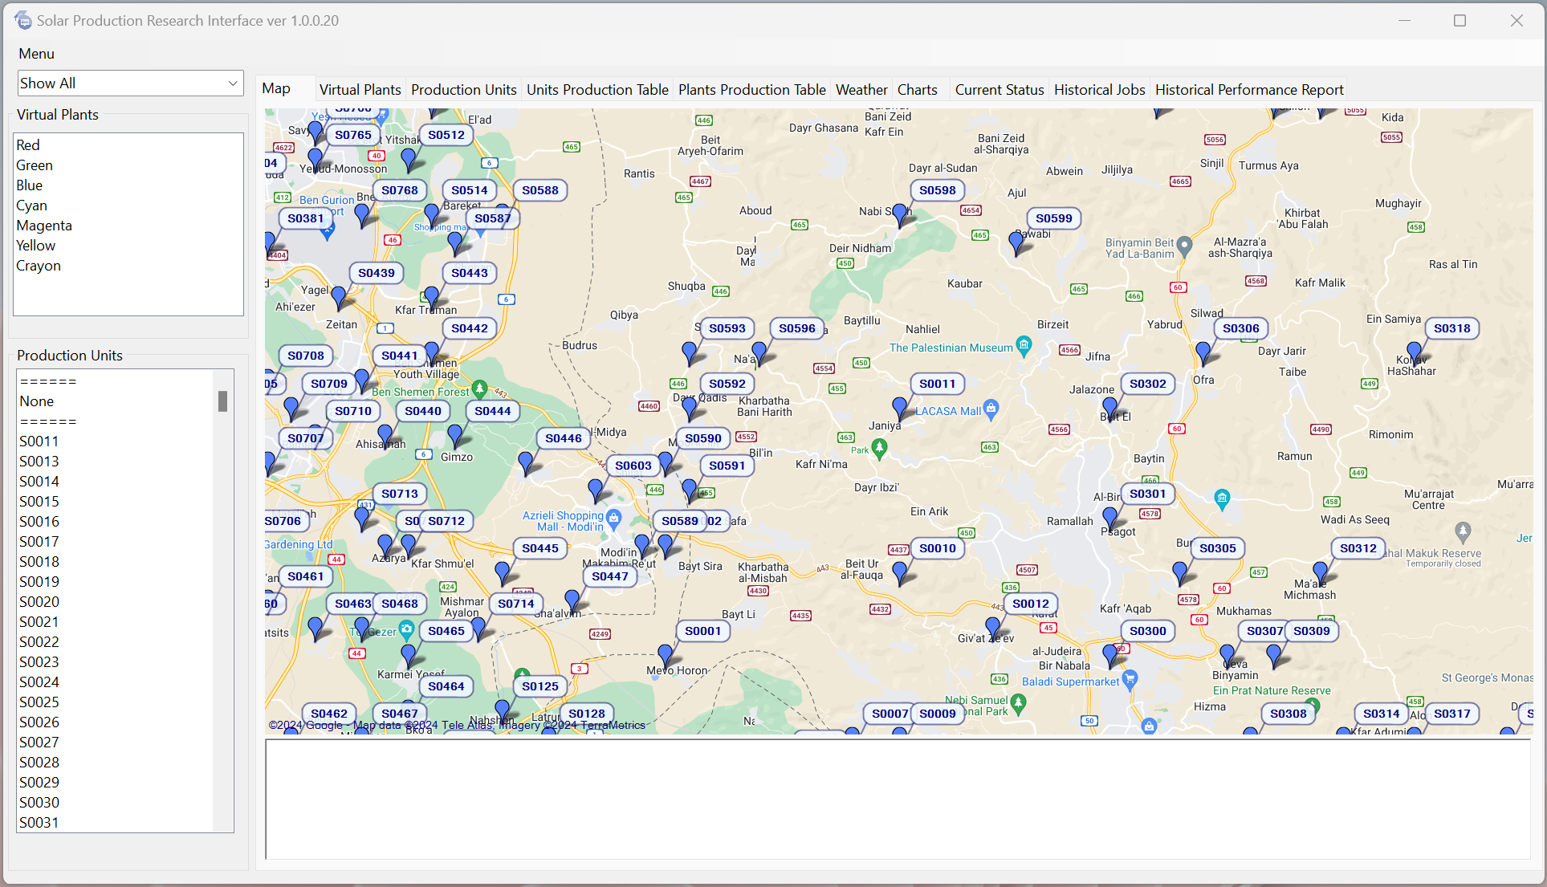
Navigating the map is effortless. Simply clicking on an item from either list will instantly zoom the map to focus on the selected unit. Additionally, users can access detailed information about the selected unit via the bottom white box on the screen. This box serves as a hub of crucial data, providing insights into the unit's performance and status. Furthermore, clicking directly on an item on the map will trigger the display of pertinent information within this box, ensuring seamless access to essential details.
Figure 1 : Map tab.

Virtual Plants

Accessing the Virtual Plants Screen
To access the Virtual Plants screen, navigate to the corresponding tab labelled "Virtual Plants," conveniently positioned adjacent to the Map tab. Here, users can immerse themselves in a comprehensive overview of their virtual plants.

Interface Overview
Upon entering the Virtual Plants screen, users will be greeted by a meticulously organised table presenting essential information about each plant. This includes the unique Unit ID, precise coordinates, detailed description, installed capacity, linked weather station, virtual or physical classification, and the radius for nearby contained production units.

Functionality
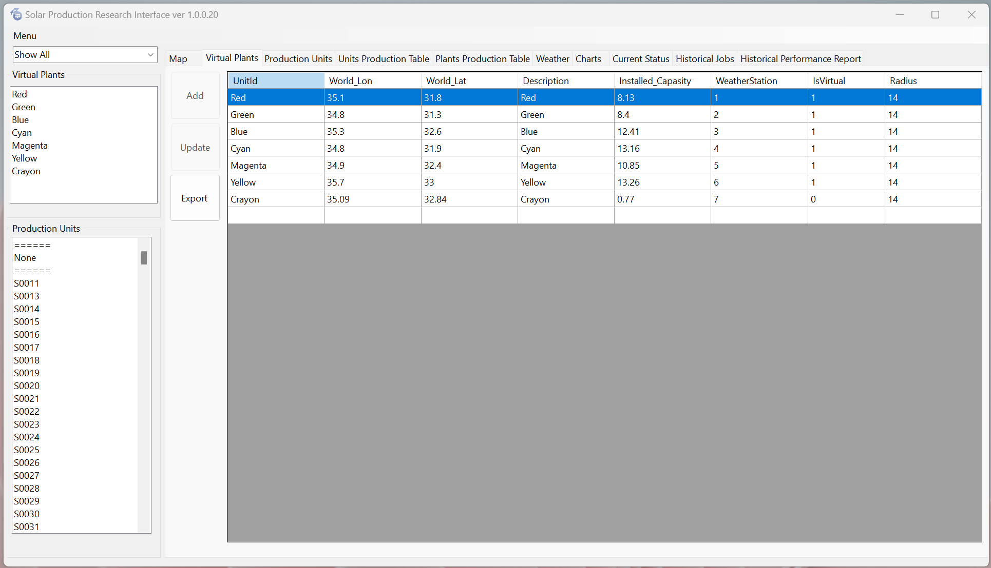
While the options to add and update plants are not currently available, users can still capitalise on the functionality to export the table data. Users can effortlessly generate a CSV file by clicking the "Export" button, streamlining data management tasks.
Figure 2 : Virtual Plants Tab.

3. Production Units

Accessing the Production Units Tab
The Production Units tab is conveniently positioned next to the Virtual Plants tab, ensuring users can swiftly access vital information regarding their production units.

Interface Overview
Upon entering the Production Units tab, users will encounter a layout reminiscent of the Virtual Plants screen. A detailed table awaits here, presenting essential information for each production unit. Users can expect to find crucial details such as the Unit ID, precise coordinates, comprehensive descriptions, installed capacity, linked weather station, virtual or physical classification, and the radius for nearby contained production units.

Export Functionality
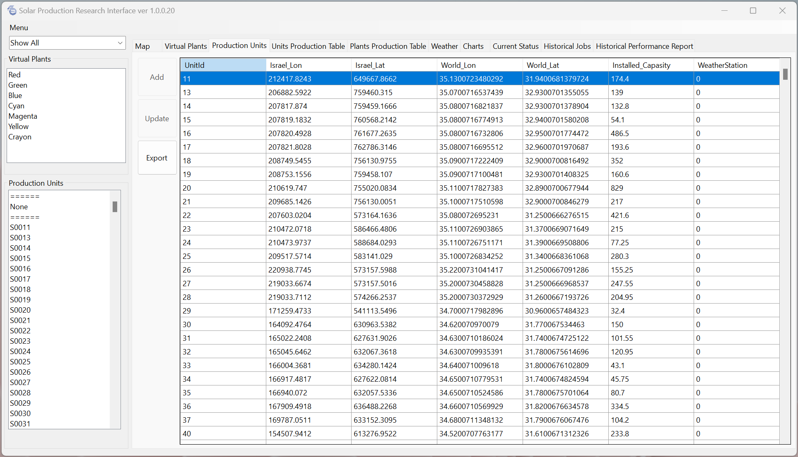
Users can easily export the table data to a CSV file like the Virtual Plants screen. Users can swiftly generate a CSV file by simply clicking the "Export" button, facilitating seamless data management and analysis.
Figure 3 : Production Units Tab.

Units Production Table
Navigate to the Units Production tab to access a comprehensive table displaying production data for selected units.
Interface Overview
Upon entering the Units Production tab, users will find a table showcasing production data for the specified units. Data selection controllers are conveniently included within this tab, enabling users to define a start and end date for the production data they wish to analyse.

Unit Selection
Users can choose which units to include in the table. The desired units are conveniently located on the left-hand side of the screen. You can choose as many units as necessary to meet your analysis needs.

List Narrowing Option
Users can narrow the list of units by selecting virtual plants from the list above for enhanced convenience. This streamlines the selection process, ensuring that users can quickly and efficiently pinpoint the units of interest.

Data Display
After selecting the desired units and defining the time frame, press the "Go" button to generate the production data table. The table will display essential information for the selected time frame, including production unit details, record ID, timestamp, reported energy, daily accumulated energy, hourly production, and the number of virtual plants contained. Users can generate a CSV file by simply utilizing the "Export" button.
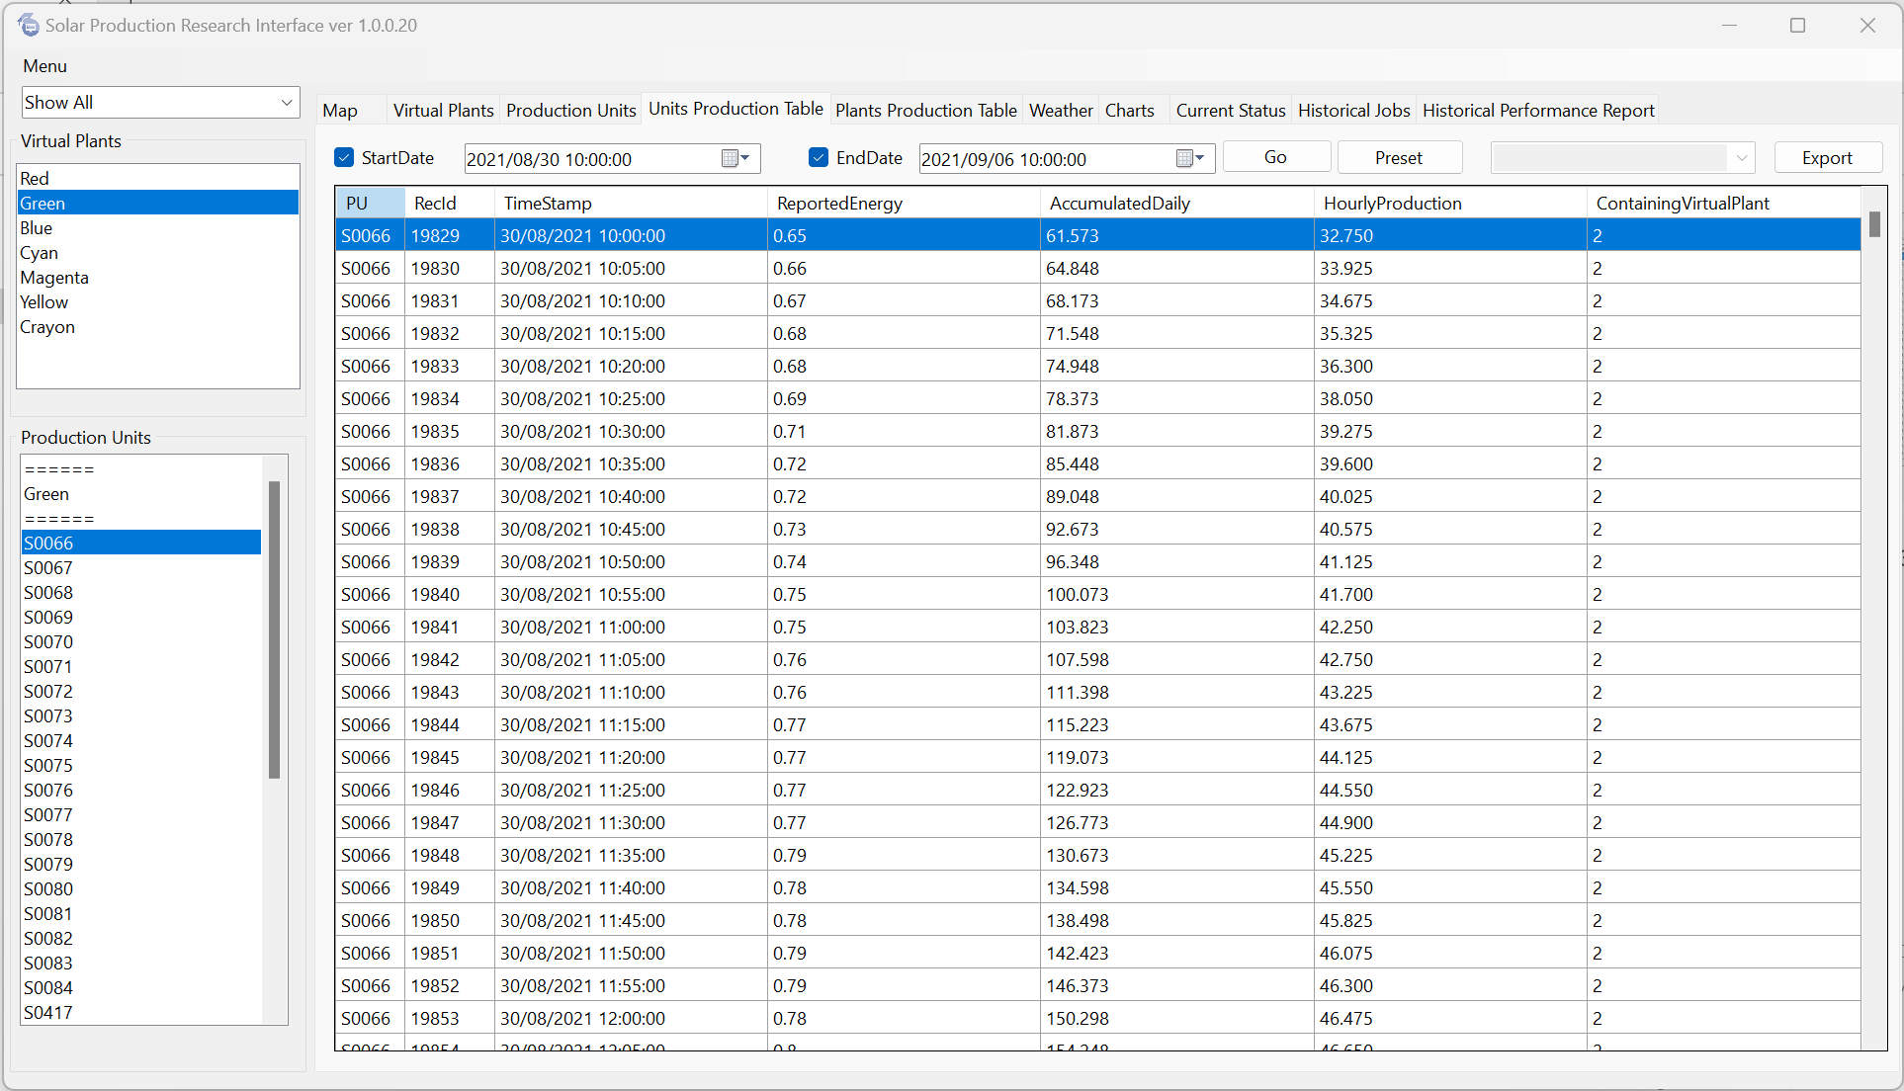
Figure 4 : Units Production Table.

Plants Production Table

Accessing the Plants Production Table
To access detailed production data for virtual plants, navigate to the Plants Production tab.

Interface Overview
The Plants Production tab contains a comprehensive table showcasing production data for virtual plants. The tab also includes date selection controllers, allowing users to define a start and end date for the production data they wish to analyse.

Unit Selection
Users can select the units they want to include in the table. Choose the desired units from the lists conveniently positioned on the left-hand side of the screen. You can select as many units as needed to suit your analysis requirements.

List Narrowing Option
Users can narrow the list of units by selecting virtual plants from the list above for ease of use. This simplifies the selection process, enabling users to identify the virtual plants of interest quickly.

Data Display
After selecting the desired units and defining the time frame, click the "Go" button to generate the production data table. The table will display comprehensive information for the selected time frame, including the virtual plant name, record ID, timestamp, hour, day of the year, current production value (y_now), output, current prediction value (y_hat), residuals, absolute residuals, predicted absolute residuals, lower prediction interval, upper prediction interval, and processing time.

Export Functionality
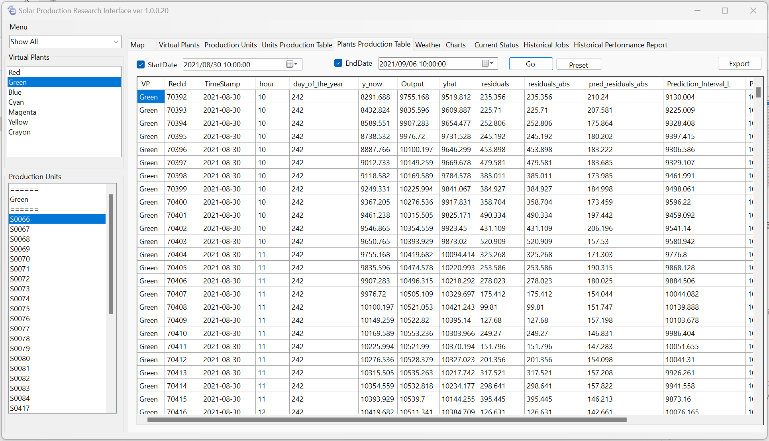
Users can export the table to a CSV file for convenient data management using the "Export" button.
Figure 5: Plants Production Table.

Weather

Accessing the Weather Tab
To access the Weather tab, locate and click on the corresponding tab labelled "Weather." Users can access detailed weather data for each station ID within a specified time window.

Data Display
Upon entering the Weather tab, users will find a comprehensive display of weather data for each station ID at the selected time window. The displayed information includes the Station ID, date, temperature in Celsius degrees, dew point in Celsius degrees, humidity percentage, pressure in millibars (MB), wind direction in degrees, wind speed in kilometres per hour (KPH), precipitation in millimetres (mm), visibility distance in kilometres (Km), sky condition, weather category, solar radiation in watts per square meter (WM2), and the Ultraviolet Index (UVI).

Functionality
To retrieve the mentioned data, users should first select a desired time window using the date and time controls provided. After specifying the time window, click the "Go" button to display the corresponding weather data.

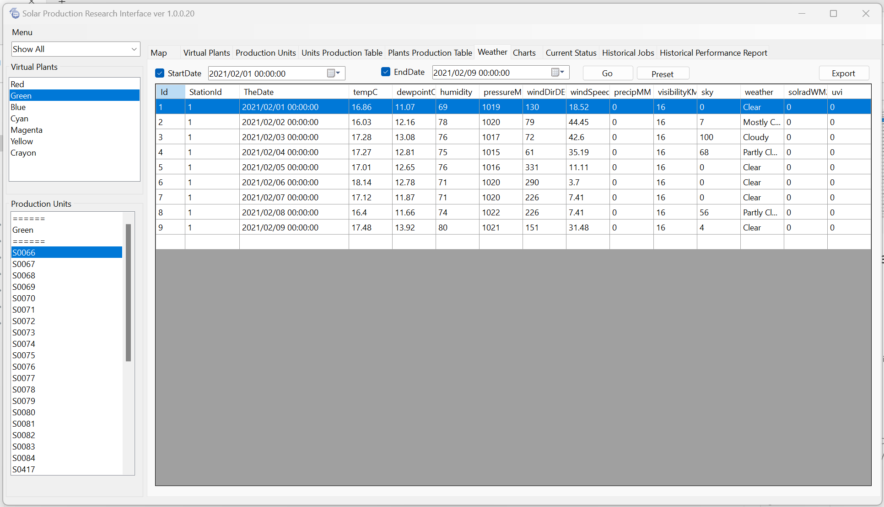
Users can export the displayed data into a CSV file by clicking the "Export" button for data exportation purposes.
Figure 6 : Weather Tab.

Current Status

Accessing the Current Status Tab
To access the Current Status tab, locate and click on the corresponding tab labelled "Current Status." Here, users can view real-time status updates for each virtual plant and various timestamps related to prediction, learning, and model building.

Data Display
Upon entering the Current Status tab, users will find a comprehensive display of crucial information for each virtual plant. This includes the current status of the plant, the last prediction timestamp, scan time in seconds, the last learning timestamp, the last model build timestamp, the first learning timestamp, and the last time the model was run.

Functionality
To view historical timestamps, users can use the date and time controllers provided to select a desired time window. After specifying the time window, click the "Go" button to display the corresponding historical data.
For data exportation purposes, users can export the displayed table to a CSV file by clicking the "Export" button.

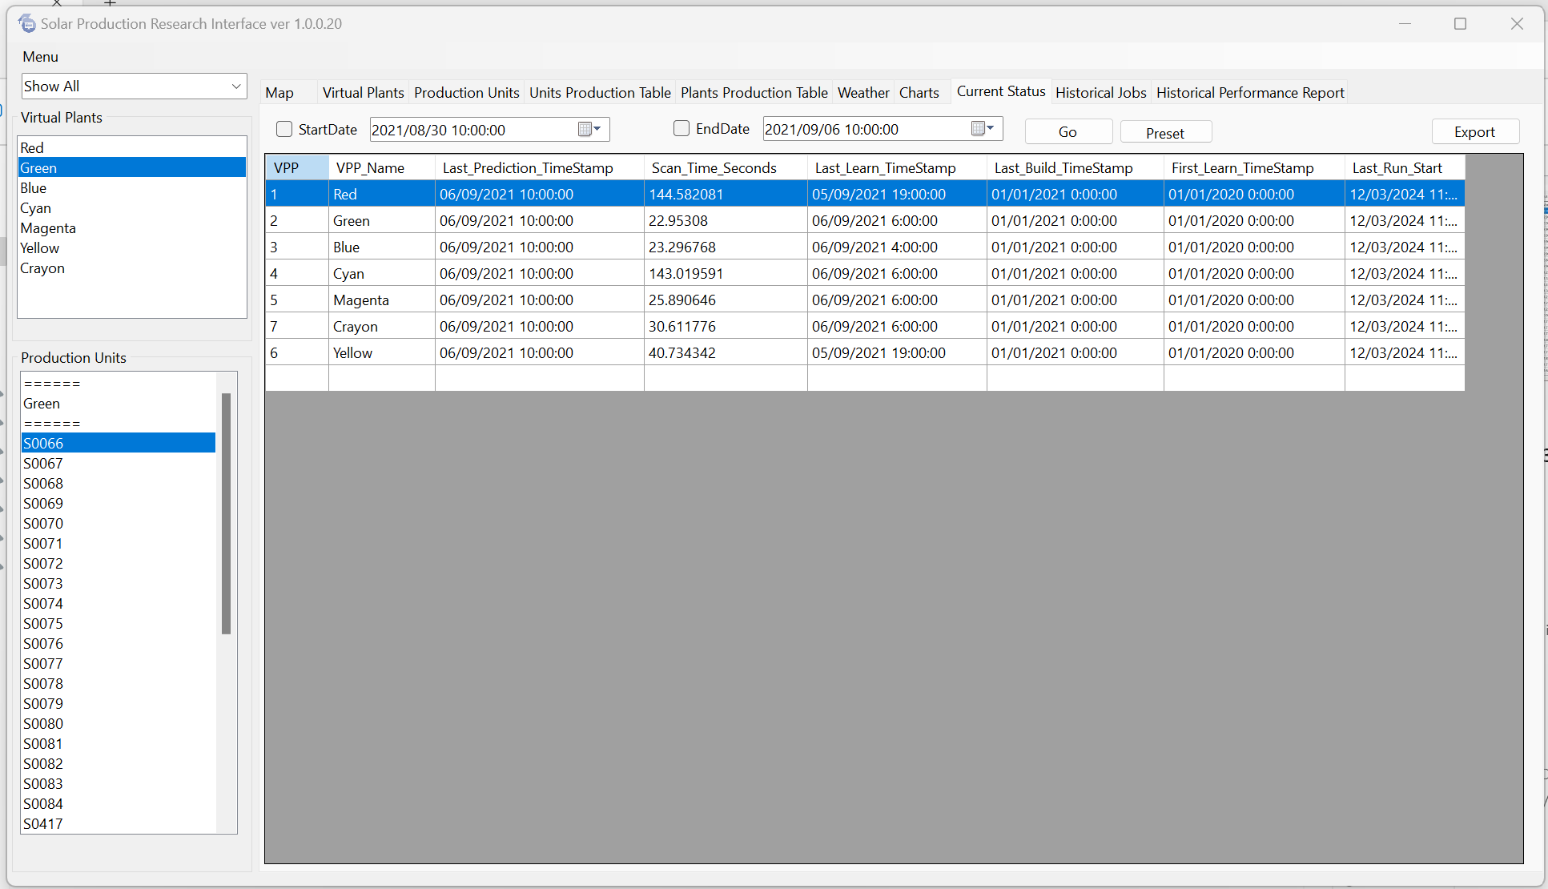
Figure 7: Current Status Tab.

Historical Jobs

Accessing the Historical Jobs Table
Navigate to the Historical Jobs tab to access a comprehensive table containing information about all jobs currently running and previously executed by the system.

Data Overview
Within the Historical Jobs tab, users will find a detailed record of each job, encompassing essential details such as the job ID, reported timestamp, running timestamp, virtual plant associated with the job, task ID, and a message indicating the job status.

Functionality

Users can specify a desired time frame using the date and time controllers above the table to customise the list of jobs displayed. After selecting the appropriate time frame, click the "Go" button to update the table with relevant job records.
Users can export the table to a CSV file by clicking the "Export" button on the tab content's right side.
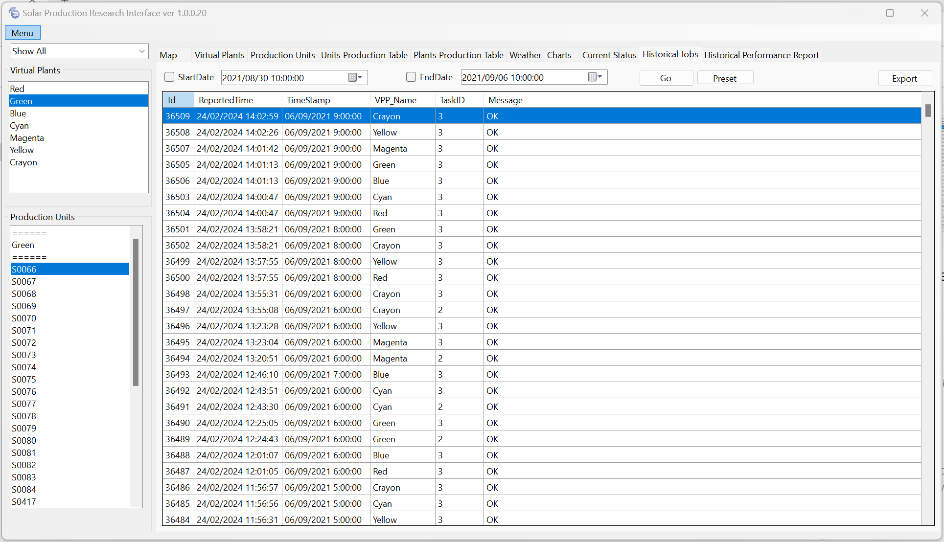
Figure 8 : Historical Jobs Tab.

Historical Performance Report

Accessing the Historical Performance Report Tab

To access detailed insights into historical performance, navigate to the Historical Performance Report tab. Here, users can explore a comprehensive report detailing deviations in kilowatts and percentages from production predictions.

Data Overview

Users will find a detailed table in the Historical Performance Report tab presenting the total deviation in kilowatts and as a percentage from the production predictions. Additionally, a grid report showcases the frequency of deviations exceeding various thresholds (e.g., 30%, 25%, 20%, 15%, 10%, 5%) in both positive and negative directions for the selected time frame and virtual plants.

Functionality

Users can customise the report by selecting the desired virtual plant from the dropdown list to the left of the date-time controllers. After selecting, clicking the "Go" button will update the data displayed according to the chosen settings.

Users can export the table to a CSV file by clicking the "Export" button.

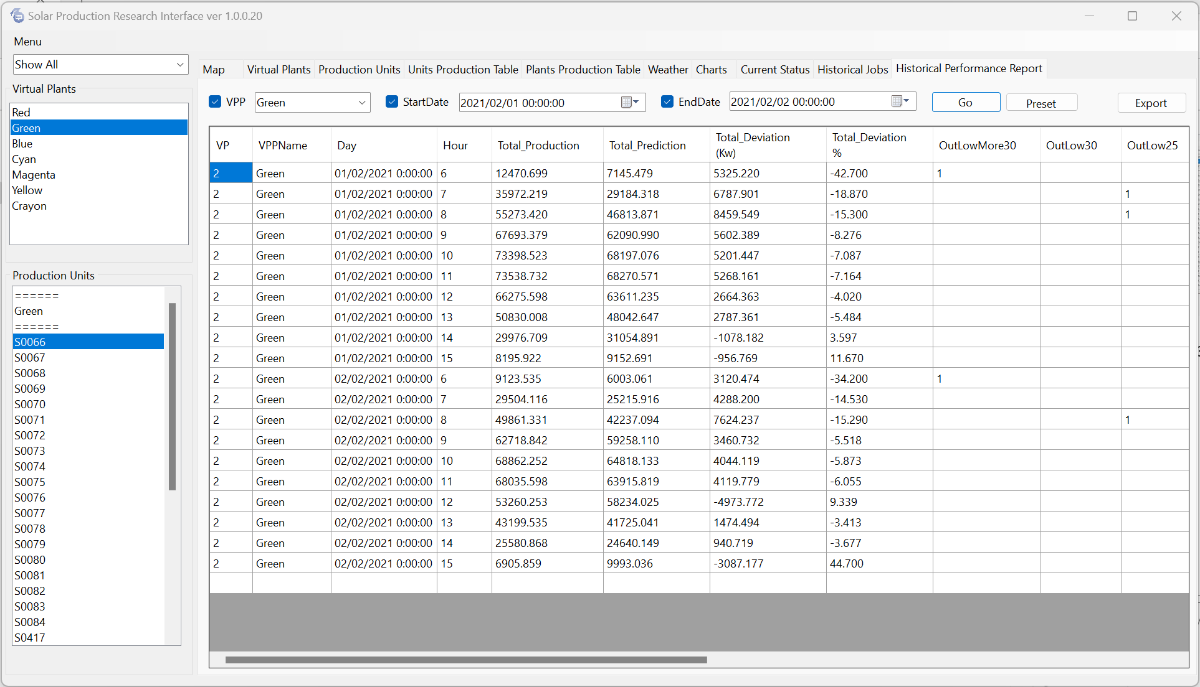
Figure 9: Historical Performance Report

Charts

Accessing the Charts Tab

Navigate to the Charts tab to visualize prediction and production data for plants and units. Here, users can access a range of functionalities for producing various types of charts.

Chart Selection

Users can select the desired chart type from the top-right drop-down menu within the Charts tab. Available options include Production by Time Windows (Absolute), Production by Time Windows (Relative), Actual vs. Predicted Chart, and Histogram Chart.

Data Selection

After selecting a chart type, users can choose a virtual plant or production unit from the lists provided on the left side of the screen. Users should mark the correct radio button in the Switches tab to define the selected list. Select "Show by Virtual Plants" to instruct the chart to use the virtual plants list, or choose "Show by Production Units" for the production units list.

Time Frame Selection

Users can select a time frame in two ways: either by specifying the number of days and hours to count backwards from the current date and time using the "On-Line" radio button or by using historical start and end times using the controllers next to the "History" radio button.

To customize time frames, users can utilize the "Select" button located to the left of the time controllers. Arrows are available for navigation relative to the start and end times. The inner two arrows move the time frame forward or backwards by one unit (e.g., if the selected time frame represents 24 hours, the shift will also be 24 hours). Conversely, the outer two arrows allow users to move the time frame by two units (e.g., 48 hours in the example of a 24-hour time frame).

Production by time window – absolute
The chart displays production over a certain time frame, including production, prediction, and low and high prediction intervals.
Follow the instructions below to produce a chart:

1. select history or on-line
2. according to your previous selection - pick a time frame
3. pick a chart type
4. in switches - pick either "show by virtual plants" or "show by production units."

5. if you have picked "show by virtual plants."
5.1. select a virtual plant from the list of virtual plants.
5.2. if you check "Show only VPP line chart for selected VP", - the production units will not show on the chart.
5.3. if you dont check the box - the chart will include the VP production and all the production units liked to this VP's output.
5.4. the selected production units on the left list will be ignored.

6. if you have picked "show by production units."
6.1. pick units from the production units on the left.
6.2. The selected virtual plants from the list on the left will be ignored.
6.3. If you select only one unit - a single line will show in blue representing the unit's production
if you select more than one, the production units will show in blue lines, and the sum of their production will show in red.

7. Then, click the chart icon button to produce the chart.

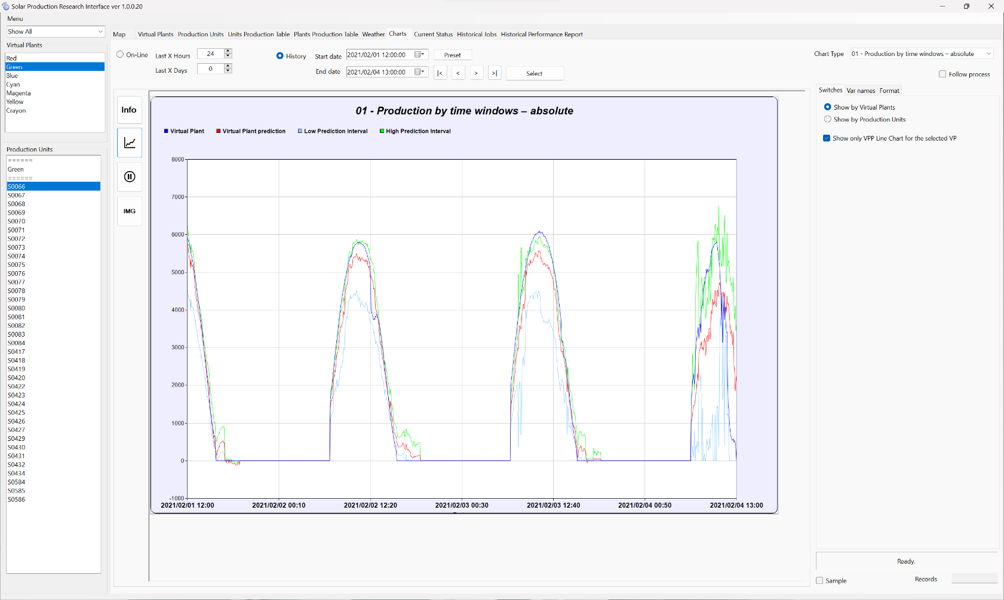
Example of the chart:
Figure 10 : Production by time window – absolute

Example of the chart when production units are selected:
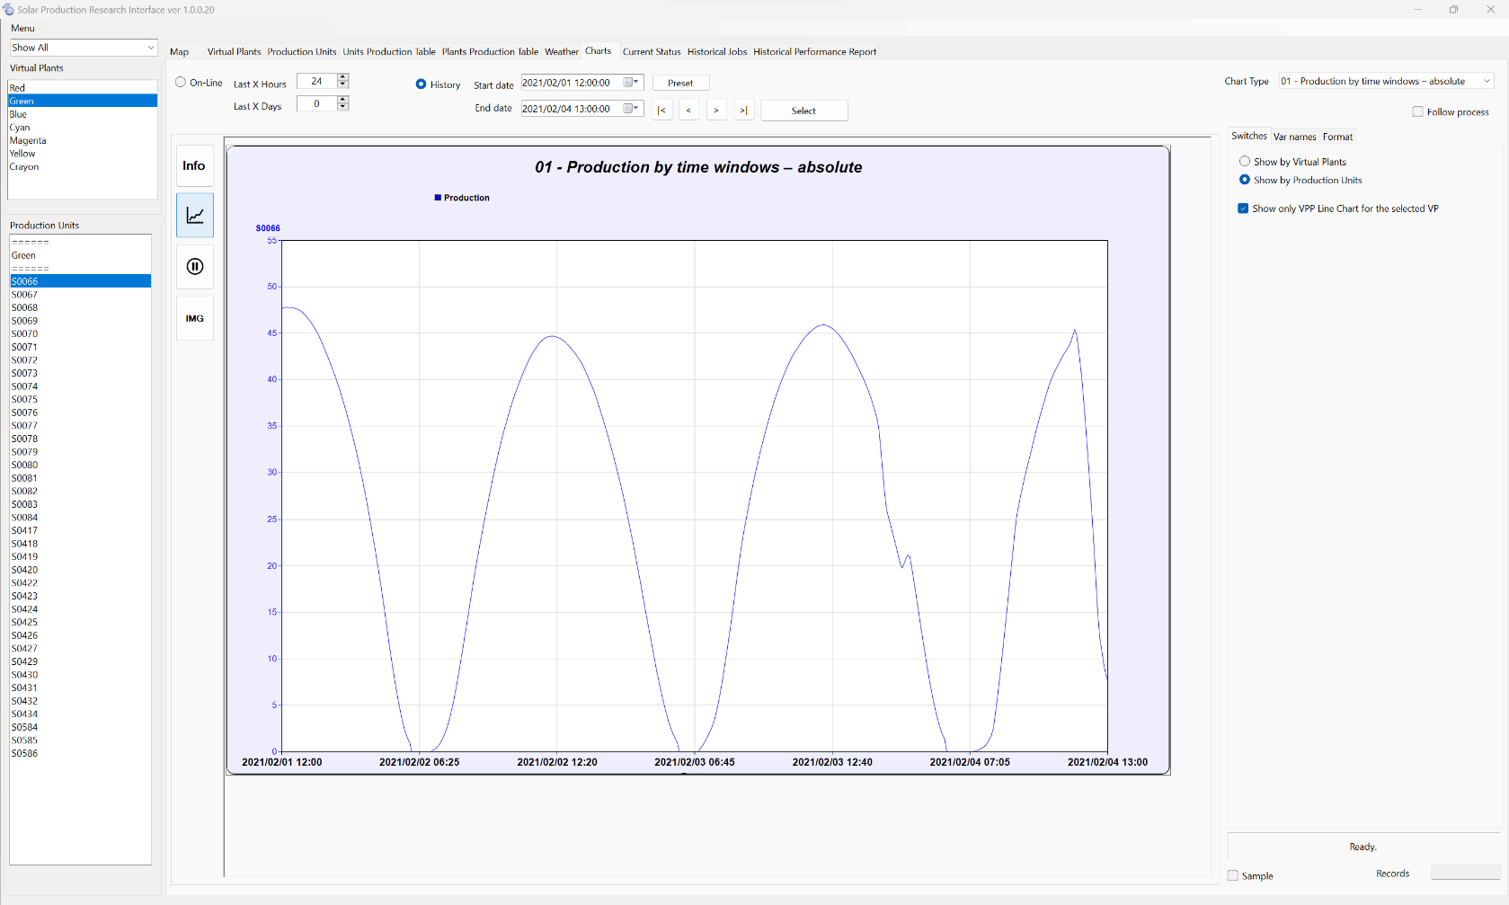
Figure 11 : Production by time window – absolute for production units.

Production by time windows – relative
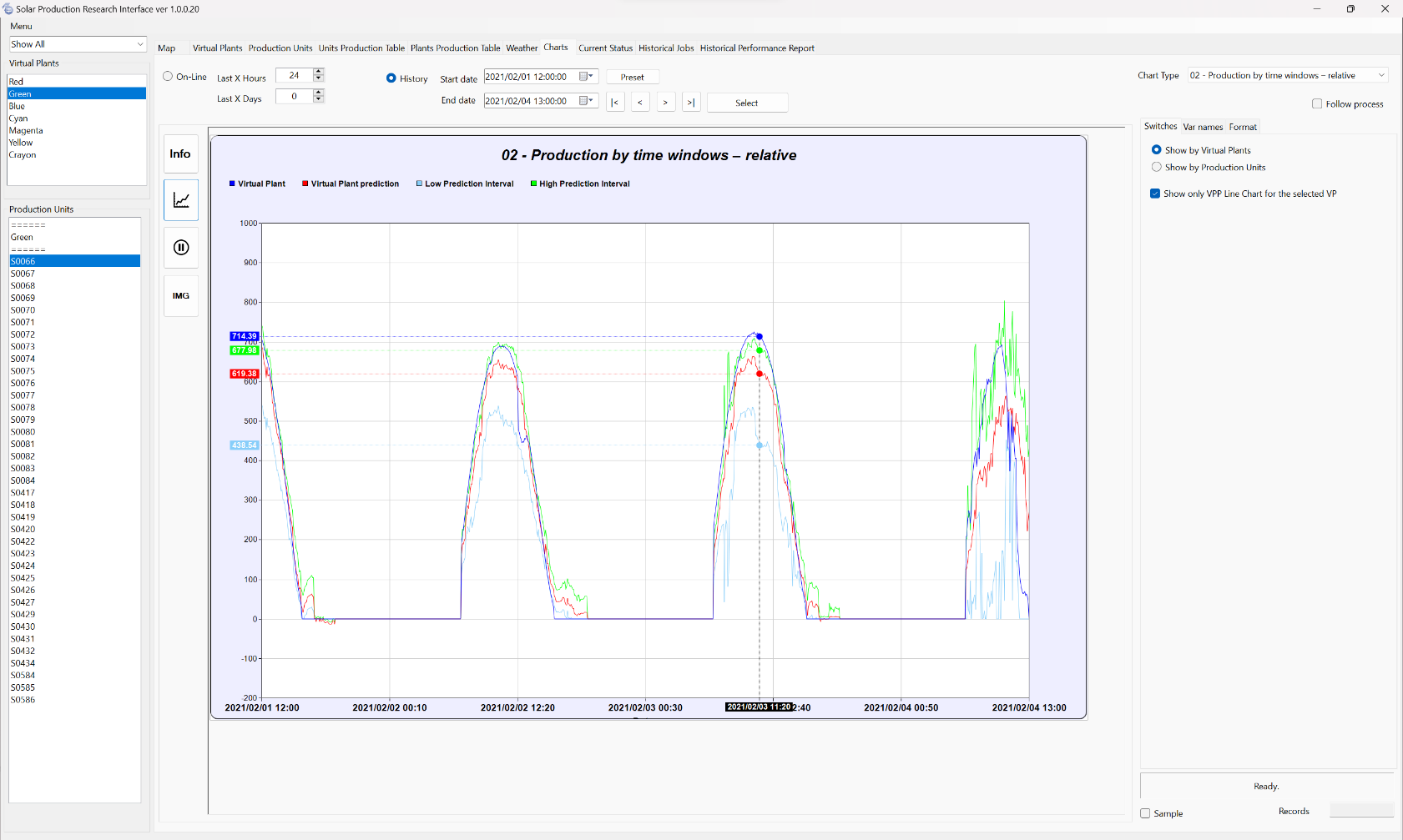
The chart you view is like Chart Number One, with a key difference: it displays relative production and prediction values instead of absolute values.
Figure 12 : Production by time window - relative

Actual vs. Predicted XY scatter chart

This XY scatter chart illustrates the relationship between actual production and prediction over time. To generate this visualisation, select the third chart type from the dropdown menu.
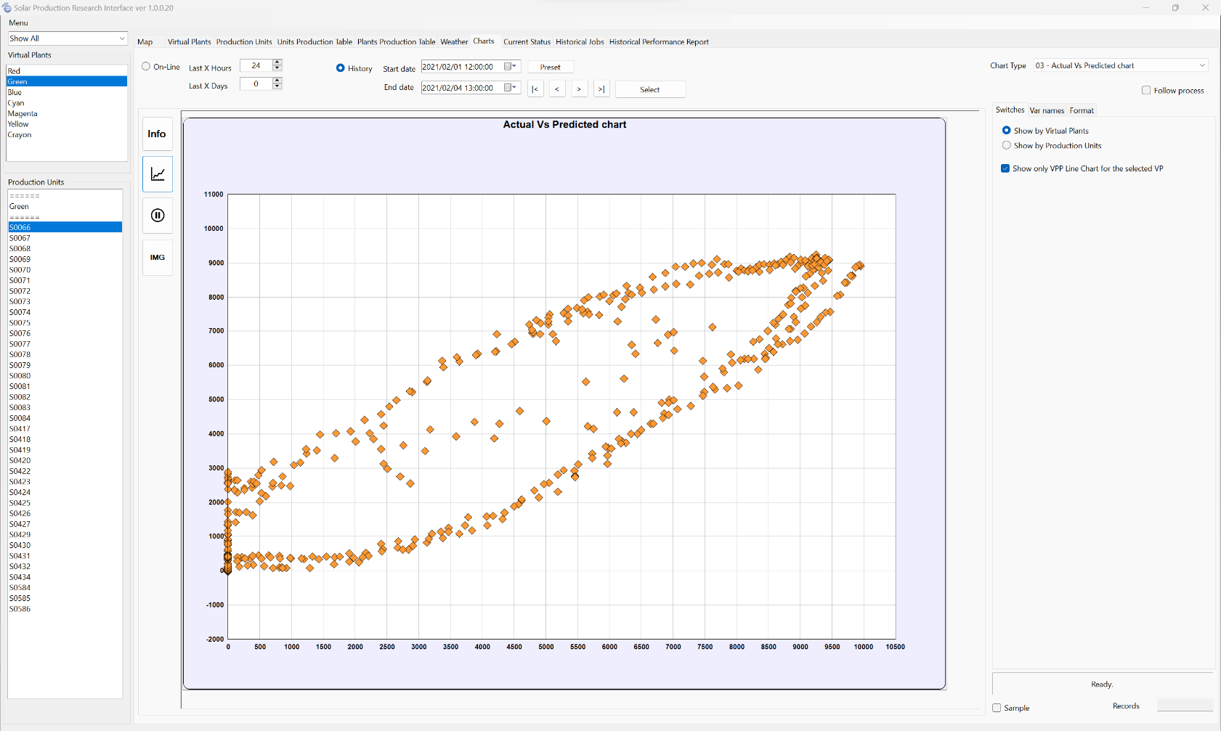
Figure 13 : Actual vs. Predicted XY scatter chart.

Histogram Chart
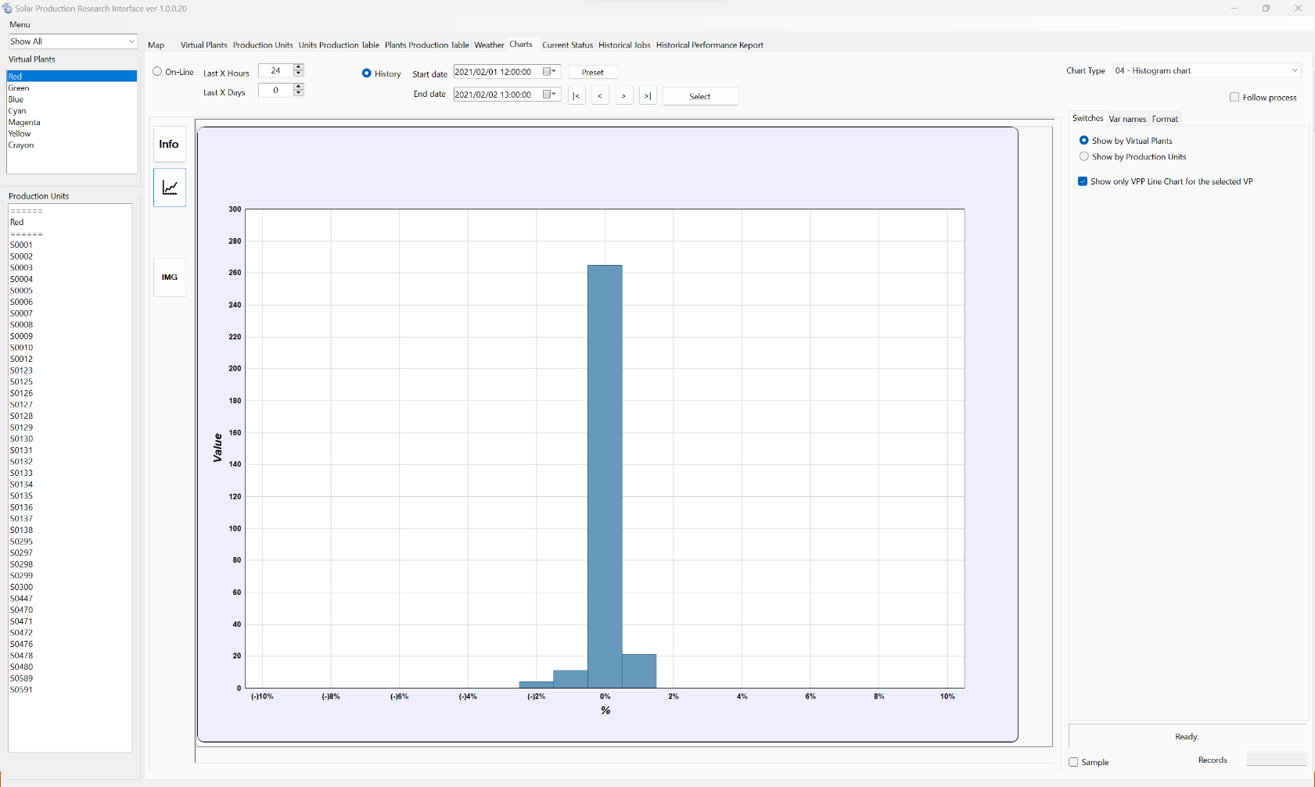
This chart visually represents the error percentage in predictions during the selected time frame. The example below shows that over 200 records had an error of less than 1 percent.
10.5. Color Selection
Figure 14:Histogram chart.
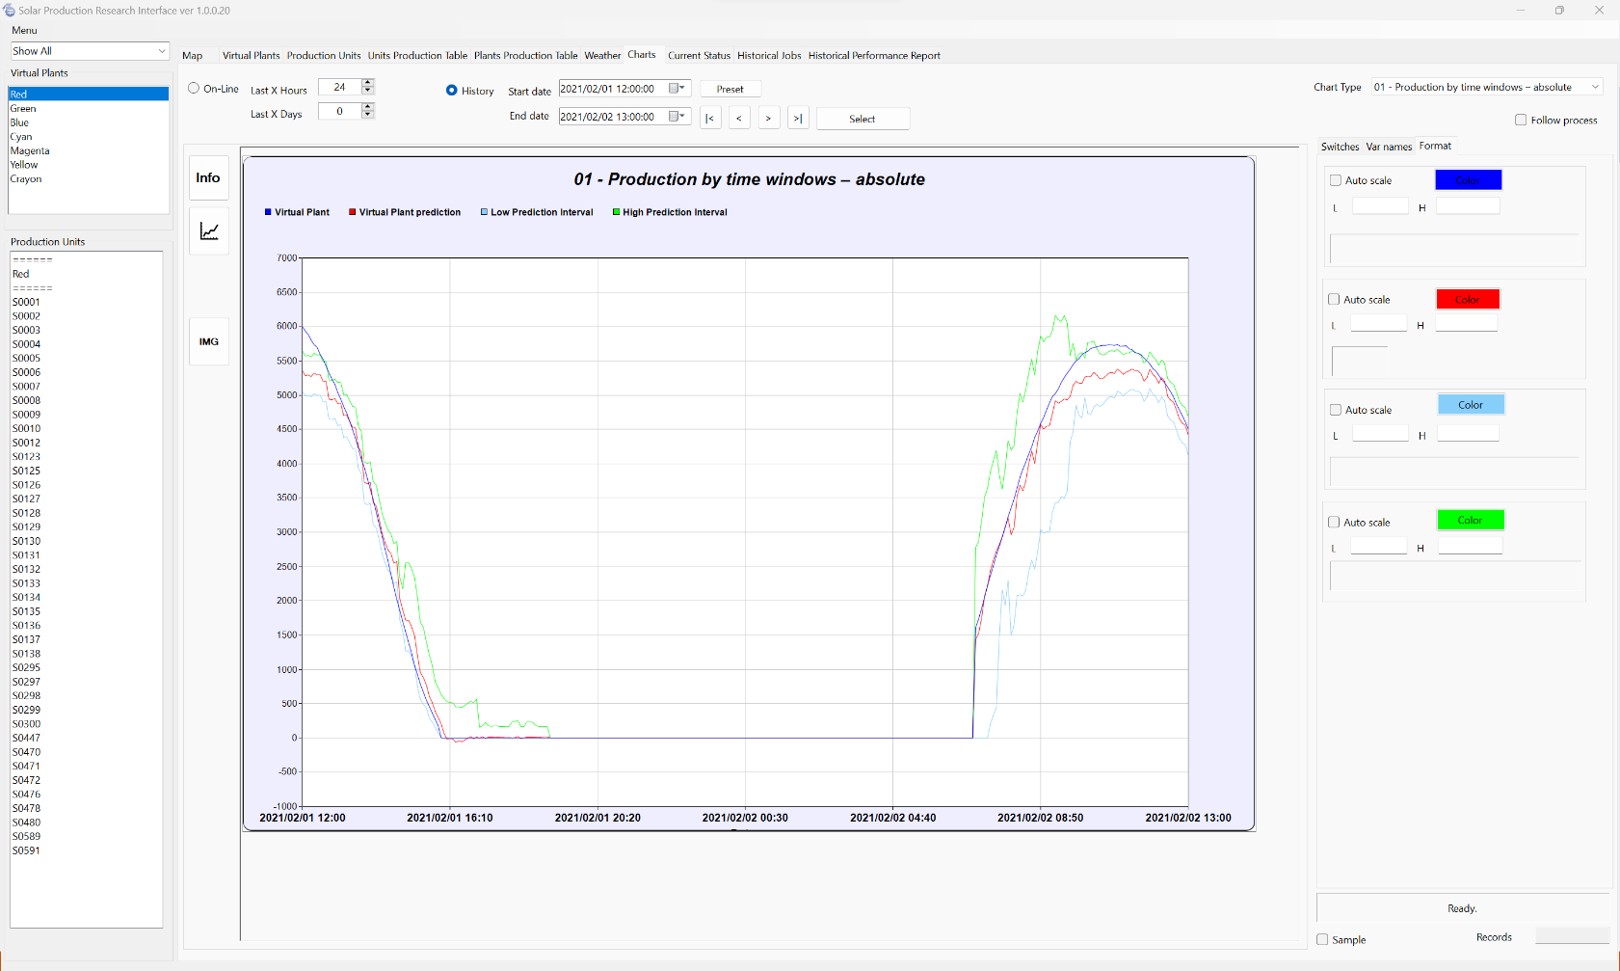
The "Format" tab allows users to select colours for different chart lines. To begin, click the coloured button associated with the line you wish to customise. This action will open the colour palette, allowing you to choose the desired colour. Once you have selected your preferred colour, click "OK" to apply the changes.
Figure 15: Color selection on the Format tab on the right.

Selecting a Custom Time Frame

To access a range of predefined time frames, click the "Select" button. This action will open a window like the one in the picture below. Within this window, users can effortlessly choose from several predefined time frames, including:
- Current Day: Covers the duration from midnight to midnight of the current day.
- Last Day: Encompasses the time frame from midnight to midnight of the previous day.
- Last Week: Represents the entire previous week.
- This Month: Spans from the 1st day of the current month to the current day.
- Last Month: Covers the period from the 1st day of the previous month to its last day.
- Last Year: Encompasses the entirety of the previous year, from January 1st to December 31st.
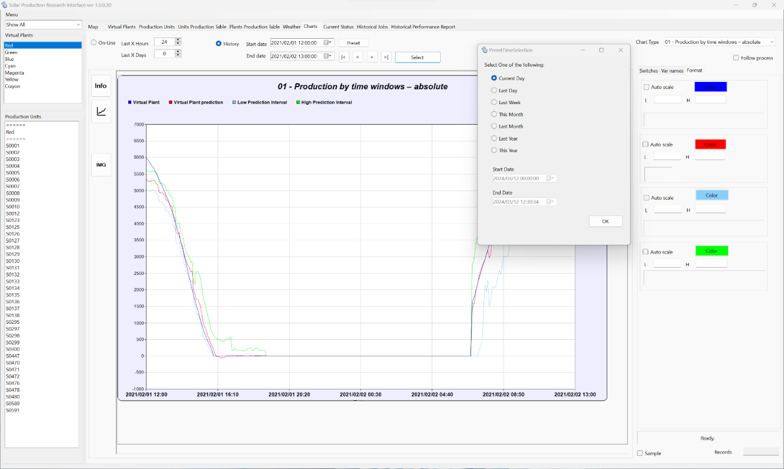
- This Year: Represents the period from January 1st of the current year to the current day.
Figure 16: Custom time frame.

10.7 Info window

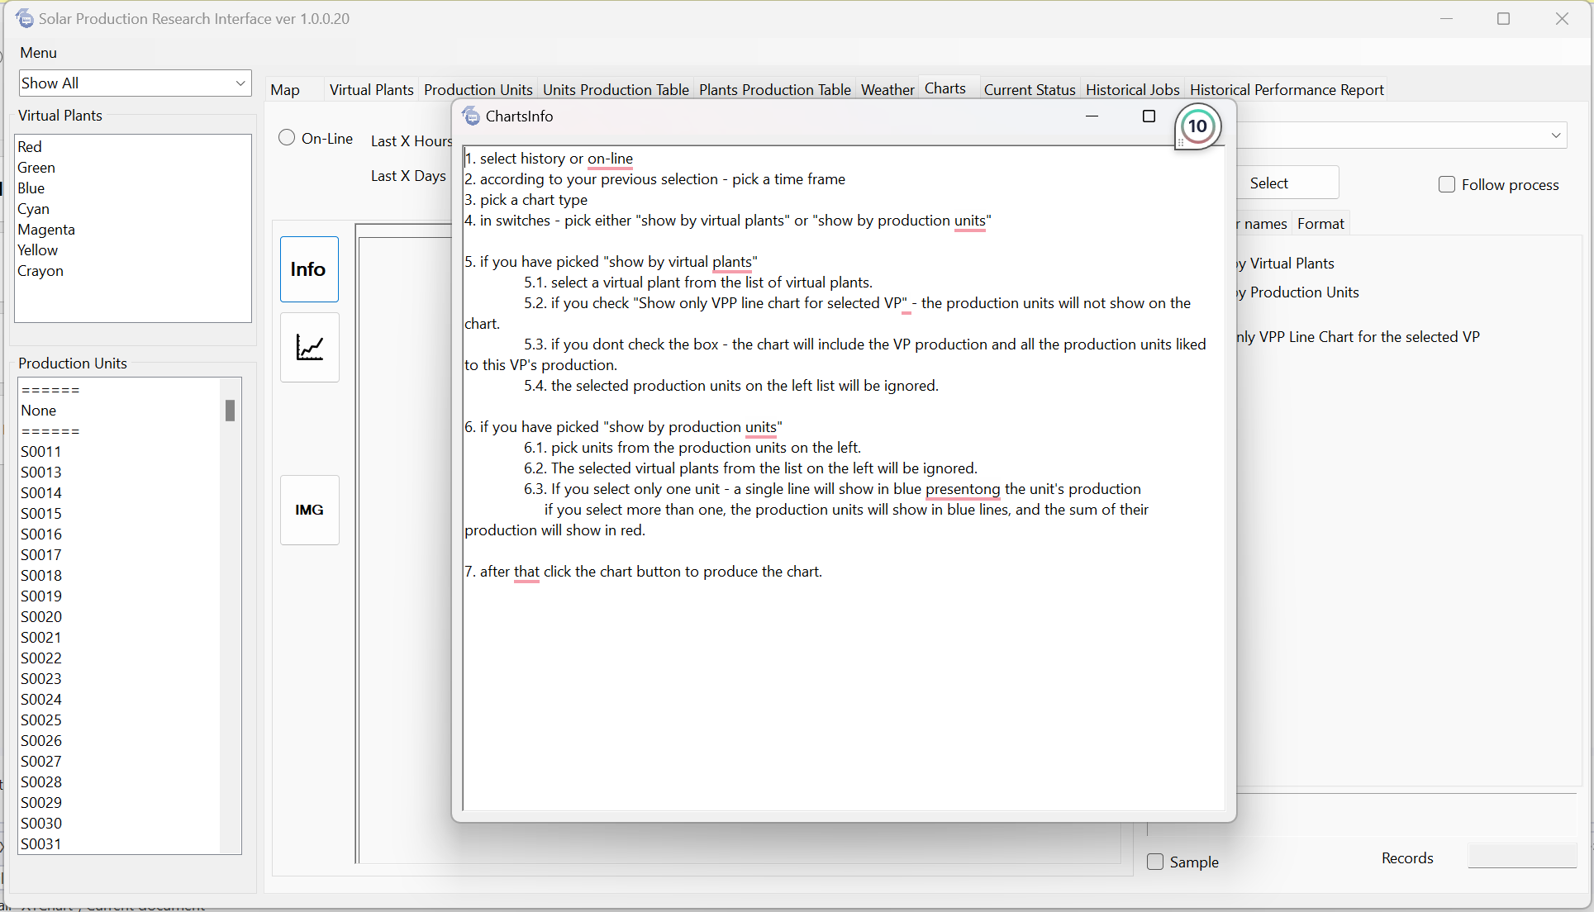
If you need help producing a chart, simply click the "Info" button. This action will open a text box containing detailed steps for creating your desired chart. Refer to this text box whenever you need guidance or clarification during the chart production process.
Figure 17: Info window after clicking info button.

